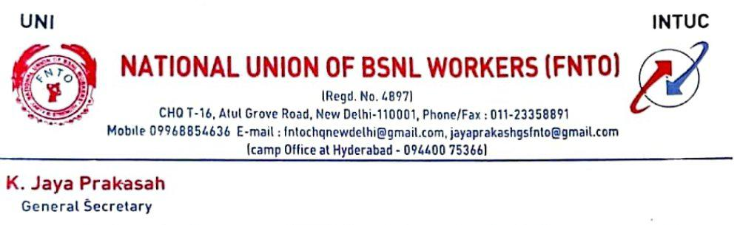
No NU/CHQ/Court Case/58/ Dated 06-10-2020
To,
Shri. Arvind vadnekar,
Director (HR),
BSNL Corporate Office,
New Delhi.
Respected sir,
We would like to invite your kind attention to the letter Preferred to GM (SR) BSNL Corporate office by the General Secretary of NFTE BSNL vide letter no TF-2/2(A) dated 28-09-2020 regarding Additional Nominations from NFTE BSNL to the staff side of the National Council.
In this regard Our Union submitting the following facts for your kind attention. The NFTE BSNL is trying to confuse the Management for their personal interest.
In this regard, we are to invite your kind attention to the stand of the BSNL reflected in the Counter Affidavit filed in the Hon’ble High Court of Kerala in W P (C) No. 13605 of 2013. The statement in the counter affidavit reads as follows:-
“ The averment in paragraph 3 of the affidavit filed in support of the above interlocutory application that it is not mandatory that the nomination to the councils must be made from among the members of the respective Unions making the nominations is not correct. Exhibit P1 Rules do not permit nomination of members of the Unions who did not secure minimum 7% of votes cast in the referendum. What is stated in paragraph VII Clause 5 of Exhibit P1 that for nomination to the Councils, preference is given to the serving members of the union than those members were not in service the nomination is not correct. The said contention will go against the spirit and intention of the referendum conducted in an industry. On the issue of formation of cartel by the Unions at the time of referendum, it was clarified by this respondent that BSNL does not

recognize any form of alliance by the Unions but gives recognition only to the majority Unions and that the formation of any alliance/consortium will not confer any right to its member Unions for grant of recognized representative status and facilities which are meant only for the majority Union in whatsoever manner. The representation in the Councils from the staff side is given by the Management only to recognize representative Unions and not to other unrecognized Unions.” And also refer your letter No BSNL/9-5/SR/2013 dated 27-6-2013.

The BSNL Management issued a letter to all CGMs vide his letter no BSNL/9-5/SR/2013 dated 27-06-2013 clearly instructed that Staff side Members nominated to the Councils belong to the recognized representative union only and not to any other union. (Copy enclosed)
Kindly refer the Contempt Case against the BSNL Management regarding Nomination of other union members in Circle/SSA Council at Jharkhand Circle, The case was referred to you vide my letter no NU/CHQ/16/Jharkhand dated 15-10-2014, Then the Management removed the other union Member Names nomination. (Copy of the letter enclosed)
Even after the clear instructions from your office letter no BSNL/5-1/SR/2015/Vol.II (iii) dated 19-05-2016 Para II, again the NFTE BSNL G.S. is trying to misguide the Management by requesting to include Additional Nominations who is not belongs any union . Shri P.N.Perumal (Rtd O.S.),he is the EX All india president of SEWABSNL and his subscription deducted Rs 20/- till his retirement 2018 from his pay& allowances for SEWA BSNL Only.
Contrary to the aforesaid stand made in the affidavit it is gathered that nomination is proposed to be made from other Unions who have not secured enough number of votes in the referendum. In this case the official is a non-member The same is clearly contrary to the affidavit filed by the BSNL. If the BSNL proceeds contrary to the affidavit, it will amount to grave contempt of Court as the BSNL has misrepresented before the High Court that it is not going to nominate anyone other than from recognized unions.
We would therefore, request the BSNL to stick to the stand in the affidavit filed before the High Court and not to nominate from other Unions or non member who have not secured enough number of votes in the referendum as otherwise, we will be constrained to file an application in contempt.
Thanking you,
Yours sincerely,
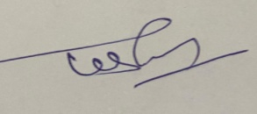

(K.Jayaprakash)
General Secretary
NUBSNLW (FNTO)
Copy to-
1. GM (SR) BSNL HQ for information please

